**Case Study: Company Operations Analysis**

**Scenario:**

Cucumber Inc. is an e-commerce company that was launched in 1995. Since then, they have their a range of operations in multiple districts of the country.

They have a high-functioning team and an excellent reputation among their customers. The firm is quite interested in doing a regular analysis on multiple domains for a perennial health check across all domains. As they have the policy to have multiple analysts review the different aspects of their businesses, **They have hired you as a Data Scientist in their data consulting team which offers services across various departments such as sales, customers, HR, etc.**

They have given you a sample of data from their databases. You have to work with the teams to help them with some of their pain points like pricing analysis, product growth, product sales, etc. as well as help them work on a new set of financial analyses and do target market/product fit analysis.

**Let’s visit the Product Information schema…**

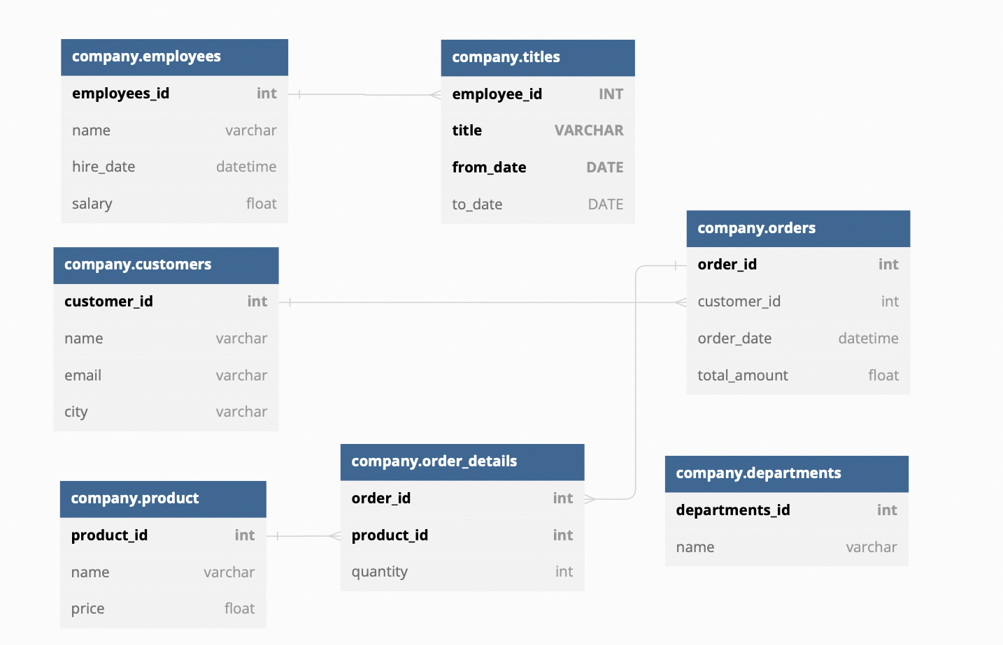

**Section 1**

The company wants to analyze its target audience. Thus the company needs to analyze the purchasing behavior of customers in the region along with high-ticket customers to ensure retention.

1. Find the names of all customers who made an order on their first visit to the website.
2. Find the names of customers who spent more than the average total amount spent by all customers.
3. Find the names and cities of customers who have made an order with a total amount greater than the average total amount spent by customers in their city.
4. Find the names of all customers who have ordered a product with a price greater than ₹ 8000.
5. Find the names of all customers who have ordered at least one of the three most expensive products.
6. Find the names of all customers who have ordered all products with a price greater than ₹ 4000.

**Section 2**

The company wants to analyze its product-market fit and wants to explore its product in terms of price, selling ability, and revenue generation.

1. For each order, find the product that contributed the most to the order's total amount, along with the quantity of that product.
2. For each customer, find the total amount they have spent on products that have a price greater than the average price of all products they have ordered.
3. Find the names of all customers who have ordered at least one product that no other customer has ordered.

**Section 3**

The HR team is interested in analyzing employee profiles of the company to ensure smooth functioning across departments.

1. Find the names of all employees whose name starts with the letter "J".
2. Find the names of all employees who were hired before January 1st, 2000, and whose salary is greater than ₹ 5,00,000.
3. For each department, find the average salary of employees who have had the title of "Manager" at any point in time.

**Section 4**

The sales team is interested in understanding the Product Market Fit and also analyzing the price sensitivity of the market. Help them with the following queries -

1. Find the names of all customers who have ordered both "Product A" and "Product B".
2. Find the names of all customers who have not ordered any product with a price greater than ₹ 8000.
3. Find the names of all customers who have ordered a total quantity of at least 10 units of "Product C".

**Section 5**

The company wants to analyze basic details about its customers.

1. Find the names of all cities where at least one customer lives, in alphabetical order.
2. Find the names of the first 5 customers whose names start with the letter "J".
3. Find the distinct first letters of all customer names, in alphabetical order.